AI use case: physical risk data extraction for green budgeting applications
1. Main area
Select the area to which the use case primarily belongs:
☐ Strategy, Governance and Organisation
☐ People, Skills and Ways of Working
☐ Data, Technologies and Infrastructure
■ AI Applications and Value Creation

2. Challenge or opportunity
Green budgeting refers to the use of budgetary policy-making tools to better understand environmental impact of spending choices, and ensure public budgets are aligned with climate and environmental objectives. According to an OECD study incorporating “green” in financial risk analysis is the least developed green budgeting method. Grave data gaps hinder developments. One key gap therein are risk-related data of assets belonging to public entities: geolocation, asset type, vulnerability.
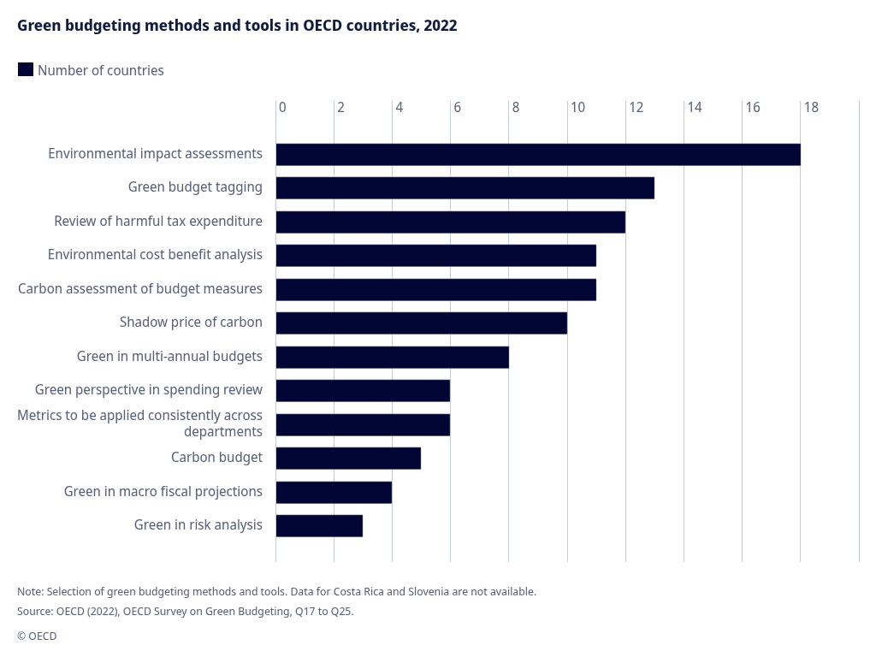

However, in many cases, public budgets do have some of these data points in an unstructured or semi-structured format. However extracting this available information in a comprehensive manner has not been done yet.

3. Proposed use of AI
Within the Hazard-Exposure-Vulnerability (HEV) risk assessment model AI can be applied to extract geolocation data (to evaluate exposure) and asset type information (to evaluate vulnerability) out of public (scope: Austrian municipalities) budget data in a structured manner.
Because this involves processing thousands of financial line items, human validation must be integrated through a workflow that balances data quality with operational feasibility.

4. Scope
Define what is included in the use case and set its boundaries.
- Local AI
- Austrian municipalities’ budget data
- Protoyping approach
- Extraction of geodata and asset classifications
Maximum: 1 short paragraph or 4 bullets.

5. Expected outcome
- Automated information extraction of physical risk data points
- Precondition for physical risk assessment of public budget
- Enable financial risk management in an environment of growing systemic climate-related risks
- The use case would demonstrate that extracting essential data gaps can be solved using
Maximum: 2 to 3 sentences.

6. Contribution to the environment and digital agenda
The use case:
Environmental contribution
- Improves/enables fiscal-environmental risk management
- Strengthens the evidence base for financial decision-making
- Supports climate especially related to green budgeting

Digital contribution
- connects financial data with GIS and other environmental data
- Builds sovereign AI capabilities
- Supports secure, reusable and scalable solutions
Maximum: 3 to 4 sentences.

7. Key conditions and considerations
- Availability and quality of digital infrastructure
- Quality of local models
- Since public budget lines don’t change significantly, running the application can be viewed as a one-time effort with scattered ad-hoc re-runs; hence, hardware-related speed constraints are not expected to be an issue

